Project Design Phase-I Solution Architecture

|  |  |
| --- | --- |
| Date | 17 October 2022 |
| Team ID | PNT2022TMID40676 |
| Project Name | Personal Expense Tracker Application |
| Maximum Marks | 4 Marks |

Solution Architecture:

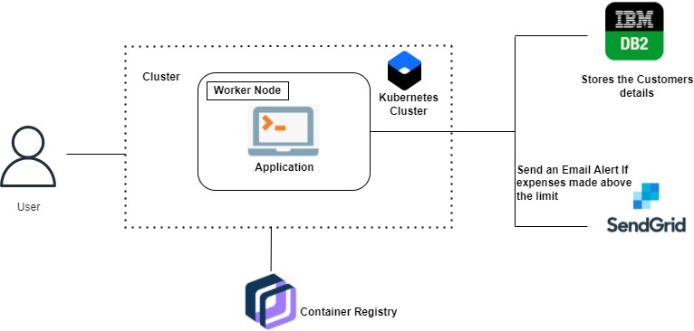

Figure 1: Architecture and data flow of the Personal Expense Tracker Application